ESD (Employability Skills Development) FA-3

Title:

Call the API through JavaScript and show it in html. Also implement all CRUD operations – Pharmacy Management

**Tools:** Microsoft Word, PhpMyAdmin, Postman

**Screenshot:**

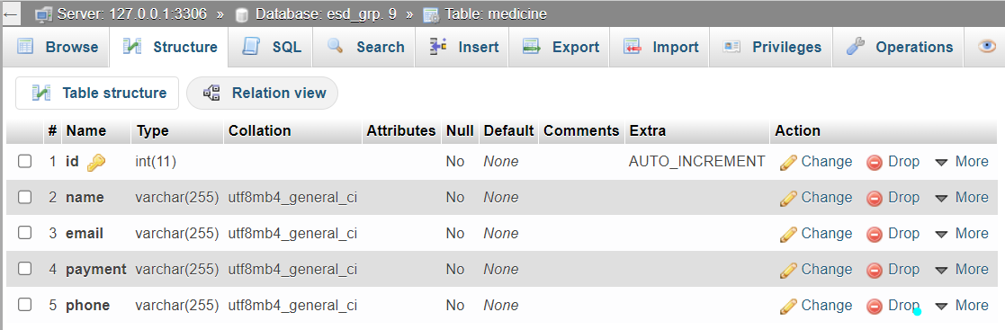 **Structure of Medicine Table**

**Table: Customer**

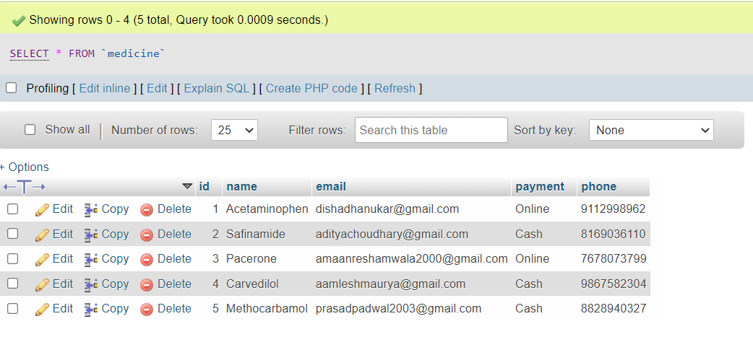

**Project Directory**

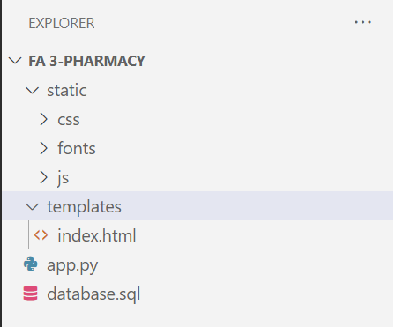

**app.py**

from flask import Flask, render_template, request, url_for, flash

from werkzeug.utils import redirect

from flask_mysqldb import MySQL

app = Flask(__name__)

app.secret_key = 'my precious'

app.config['MYSQL_HOST'] = 'localhost'

app.config['MYSQL_USER'] = 'root'

app.config['MYSQL_PASSWORD'] = ''

app.config['MYSQL_DB'] = 'esd_grp. 9'

mysql = MySQL(app)

@app.route('/')

def Index():

    cur = mysql.connection.cursor()

    cur.execute("SELECT * FROM medicine")

    data = cur.fetchall()

    cur.close()

    return render_template('index.html', medicine=data)

@app.route('/insert', methods = ['POST'])

def insert():

        flash("Data Inserted Successfully")

        name = request.form.get('name')

        email = request.form.get('email')

        payment = request.form.get('payment')

        phone = request.form.get('phone')

        cur = mysql.connection.cursor()

        cur.execute("INSERT INTO medicine (name, email, payment, phone) VALUES (%s, %s, %s, %s)", (name, email, payment, phone))

        mysql.connection.commit()

        return redirect(url_for('Index'))

@app.route('/delete/<string:id_data>', methods = ['GET'])

def delete(id_data):

    flash("Record Has Been Deleted Successfully !!!!!!!!!!!!")

cur = mysql.connection.cursor()

    cur.execute("DELETE FROM medicine WHERE id=%s", (id_data,))

mysql.connection.commit()

    return redirect(url_for('Index'))

@app.route('/update', methods=['POST'])

def update():

    id = request.form['id']

    name = request.form['name']

    email = request.form['email']

    payment = request.form['payment']

    phone = request.form['phone']

    cur = mysql.connection.cursor()

cur.execute("""

        UPDATE medicine

        SET

name=%s,

email=%s,

payment=%s,

phone=%s

        WHERE id=%s

    """,

(name, email, payment, phone, id))

    mysql.connection.commit()

flash('Data Updated Successfully')

    return redirect(url_for('Index'))

if __name__ == "__main__":

    app.run(debug=True)

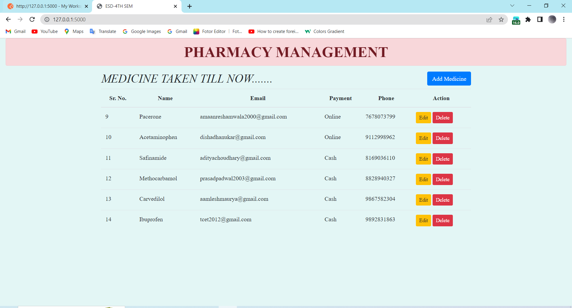**MAIN WEB PAGE**

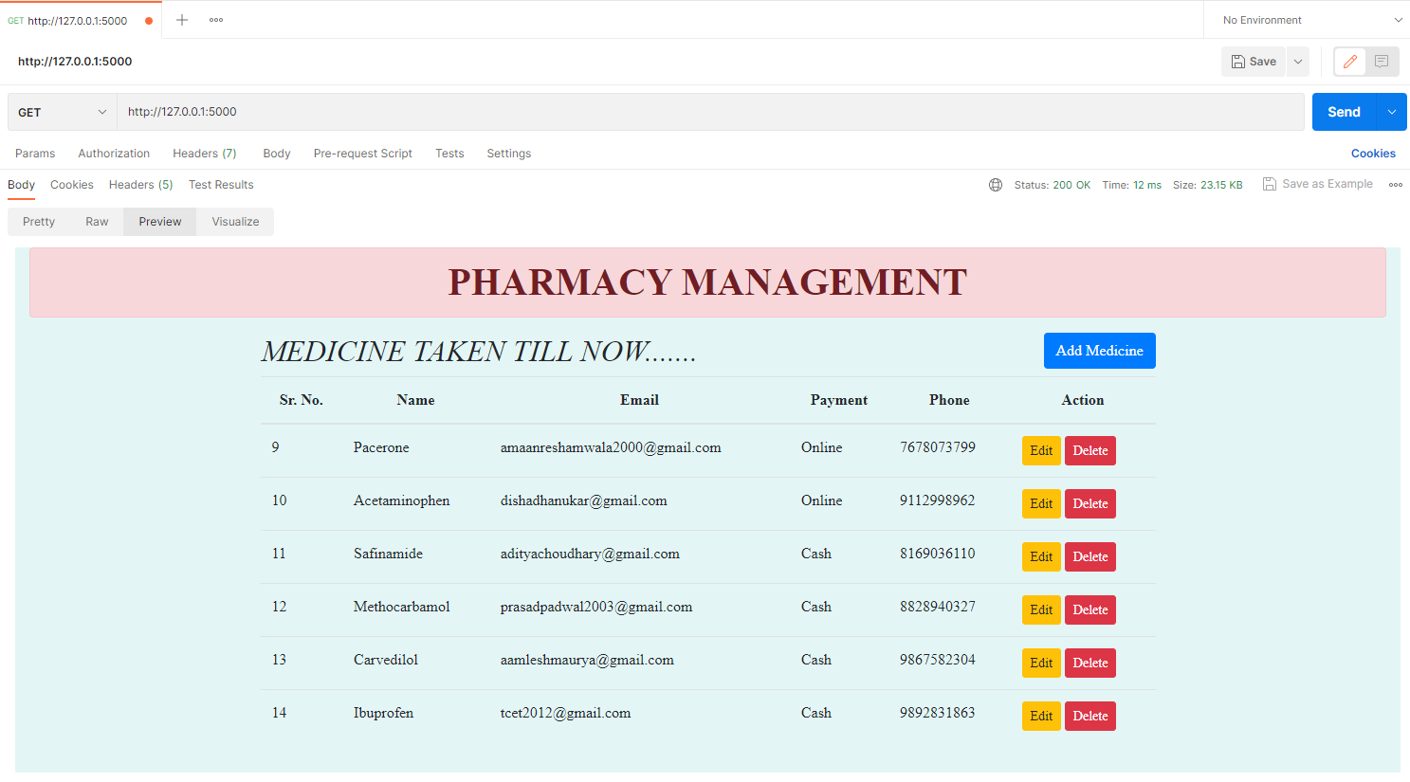**SHOWING THE MEDICINE TAKEN BY THE CUSTOMER THROUGH GET METHOD**

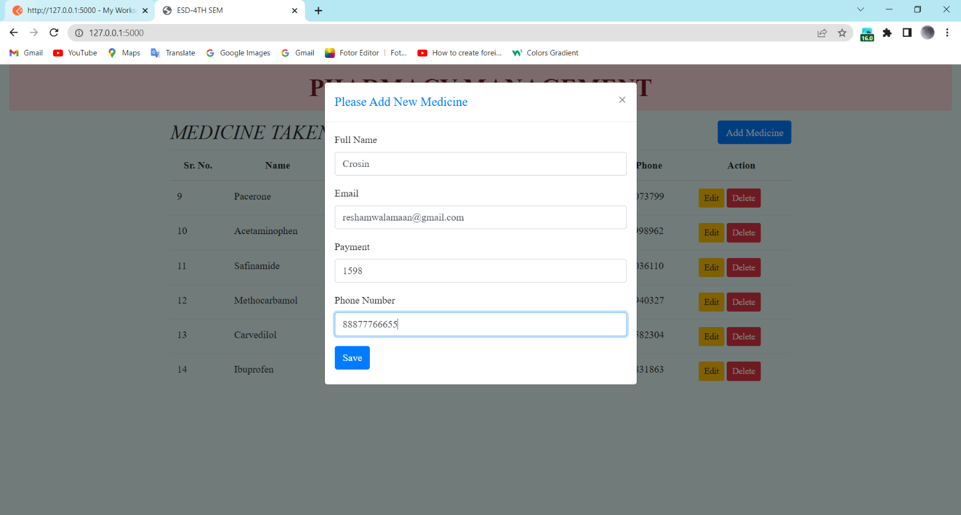**ADDING THE NEW MEDICINE**

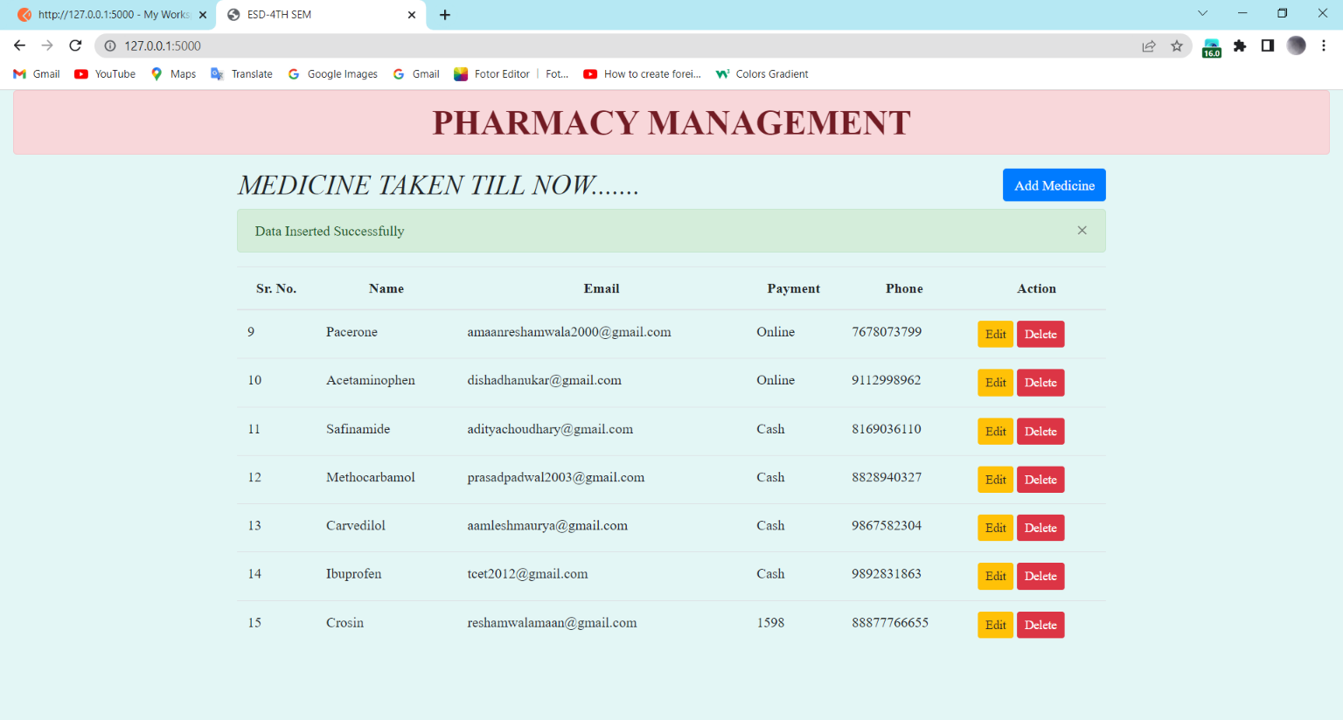

**ADDING THE NEW MEDICINE THROUGH API**

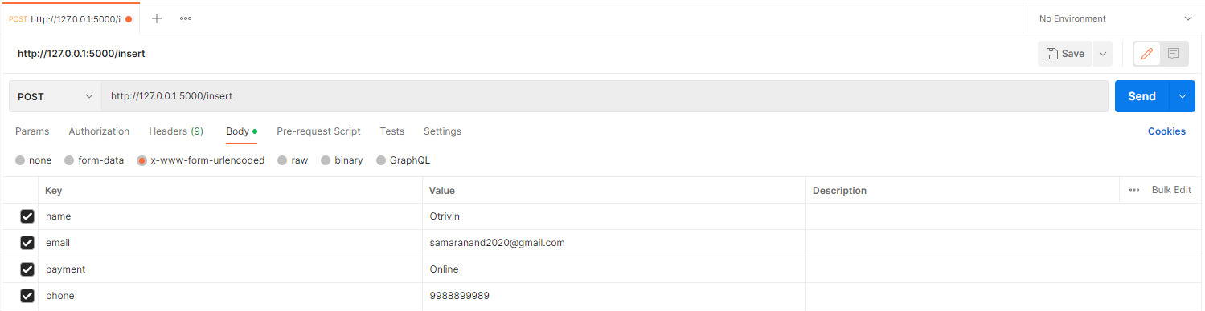

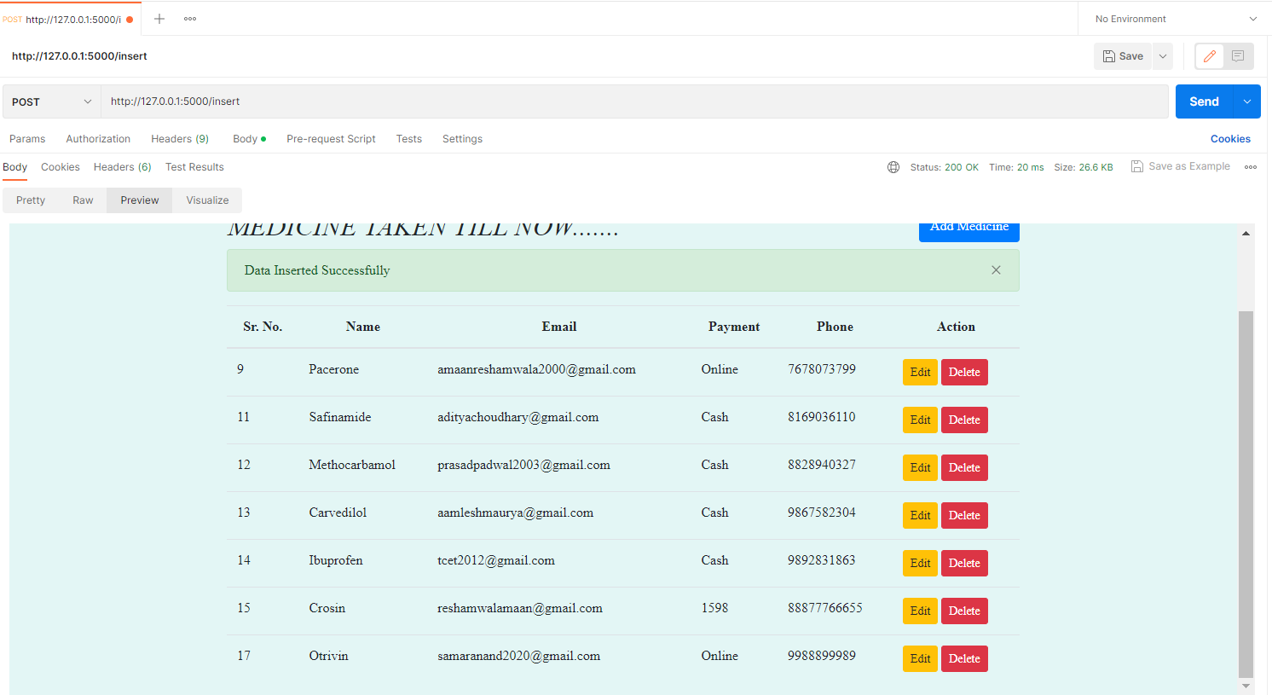



***Database after performing Insertion via API***

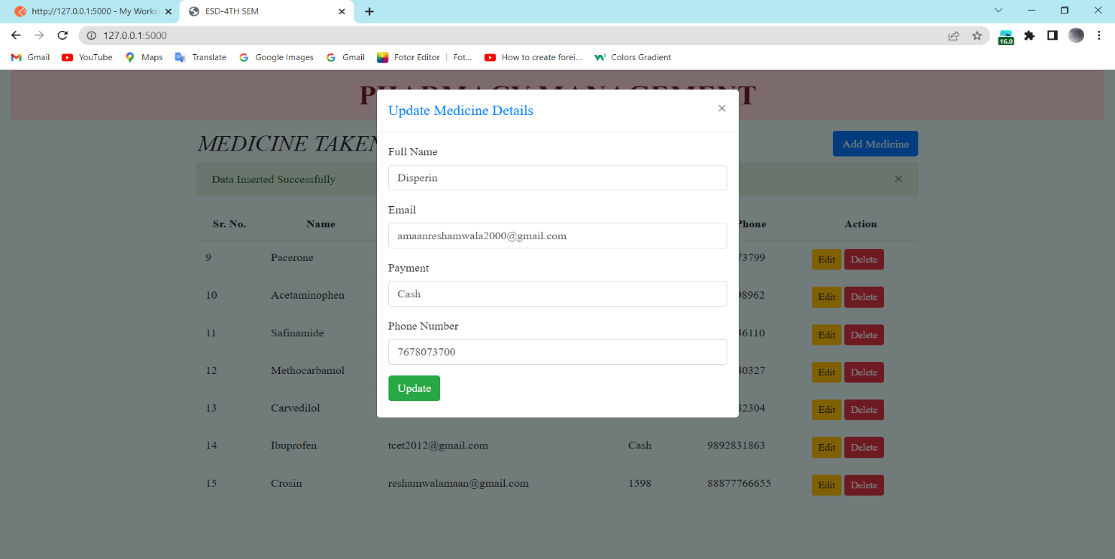**UPDATING THE MEDICINE**

***Entering the details to update from the Edit Button***

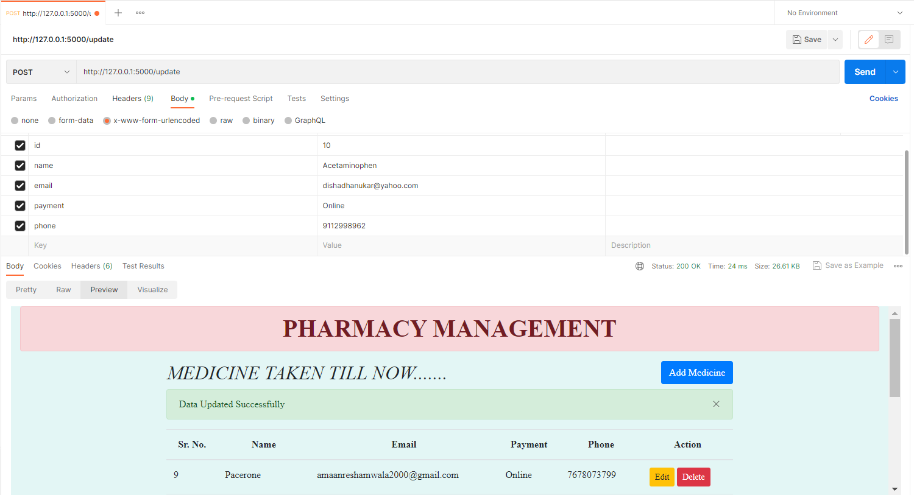 ***Add the key-value pairs for the data you want to update in the table***

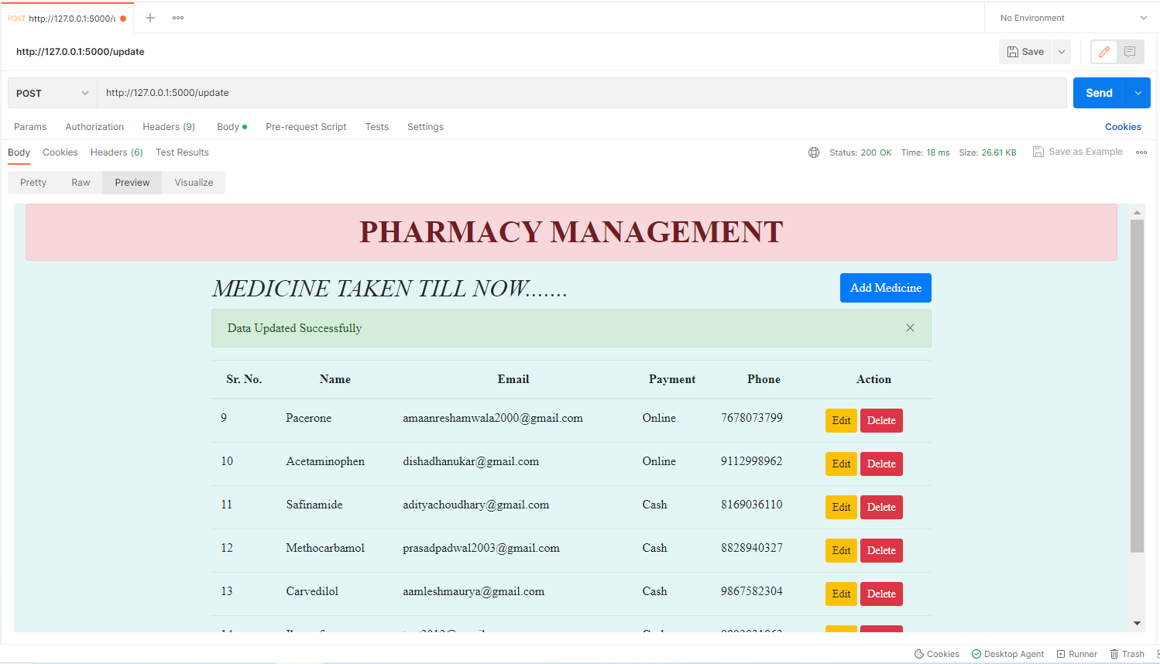

***Updating a record by calling the API***

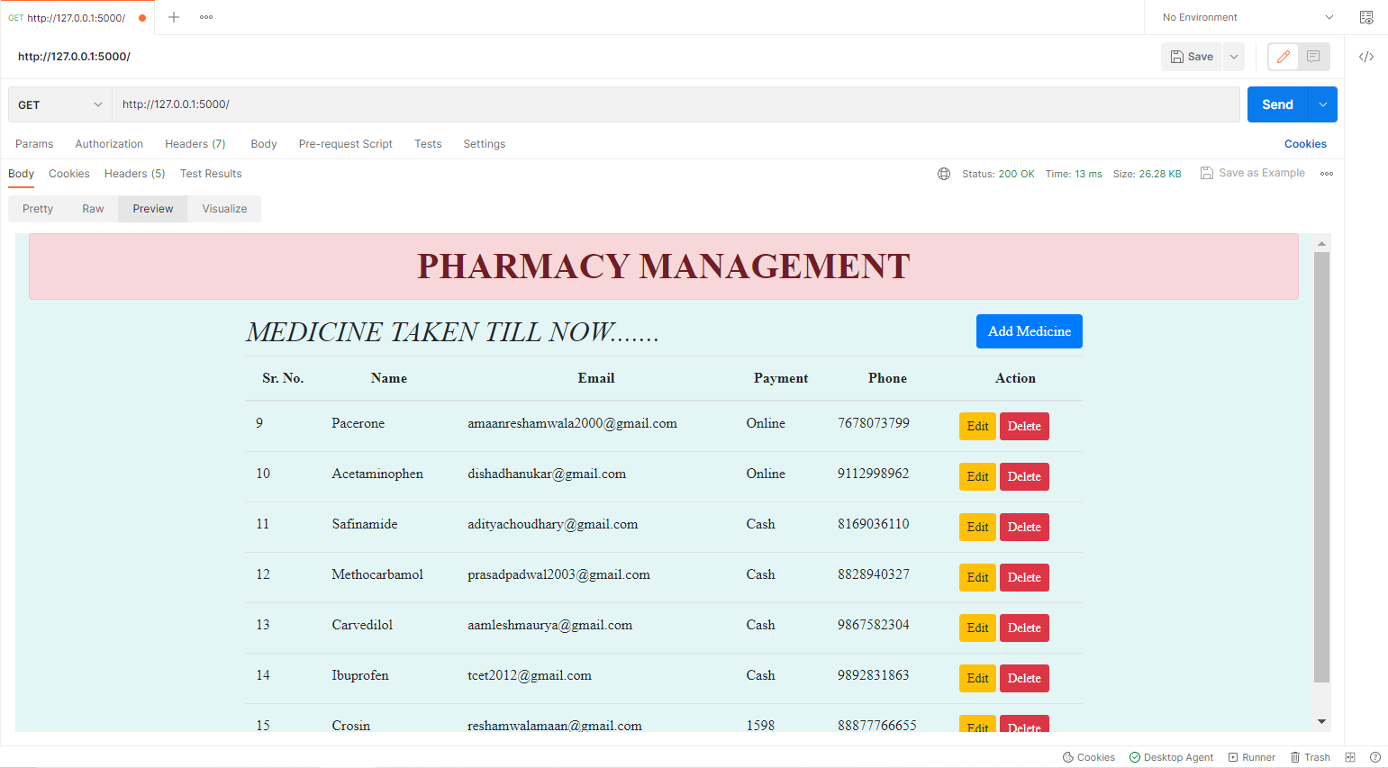**DELETING THE MEDICINE**

***Before deleting a record by calling the API***

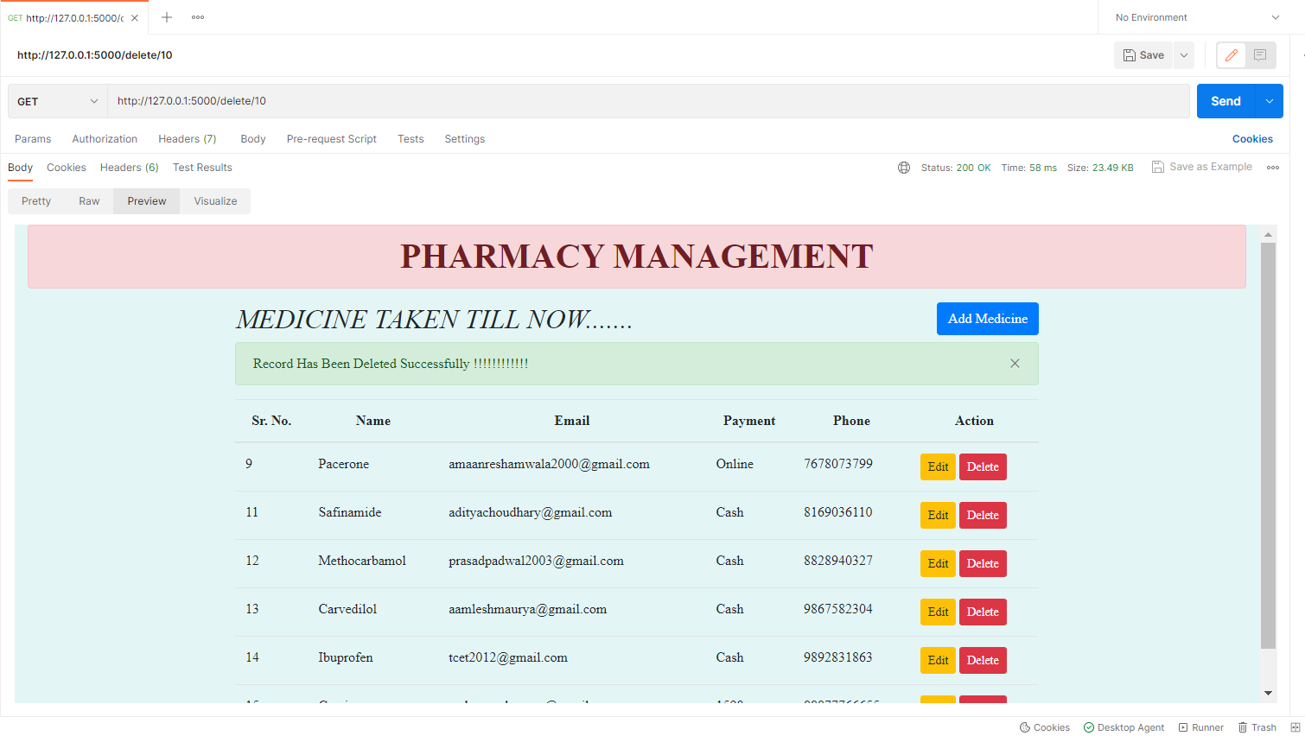

***After deleting a record by calling the API***

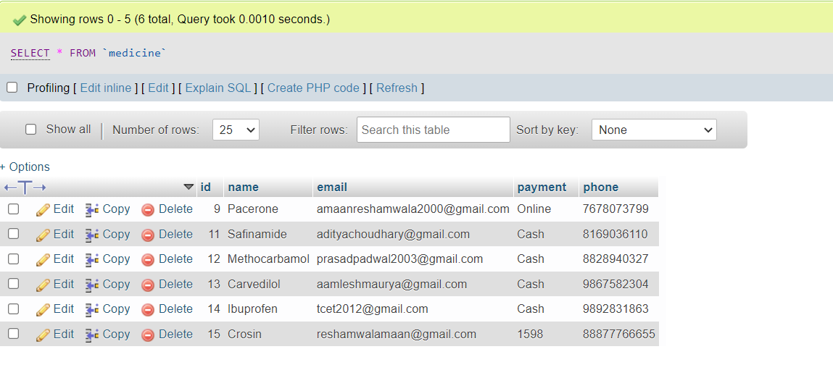

***Database after performing the CRUD operation i.e. Delete***